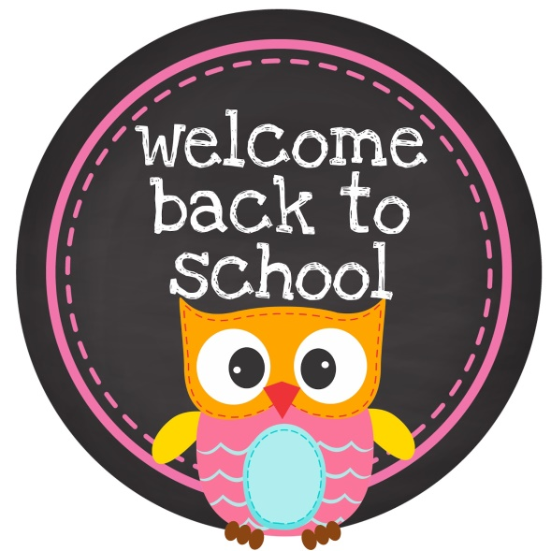
Dear Parents/Guardian,
Welcome to our classroom! I would like to introduce myself, as well as share the expectations for the 2016-2017 school year. My name is Liliana Heredia. I graduated from Metropolitan State University in the Fall of 2015 with a Bachelors Degree in Behavioral Science and Elementary Education. I completed my student teaching at Belle Creek and now I am very excited to be working here in Second Grade!

School Notes
School Notes is a classroom website that will serve as a tool parents/guardians can use to see what is happening in our classroom each week. The website will be updated every Monday containing learning content, homework, spelling words, upcoming events, and special schedules.

Homework
This year second graders will be receiving planners for the first time. Please be aware that any homework your student receives will be placed in their green homework folders. Completed homework should be placed back into their homework folders to return the next day. Please ensure homework is not placed in Thursday folders, as I do not check those. At the beginning of each week, students will write down the spelling words in their planners which can also be found on the School Notes website. Language Arts, Spelling or Math homework sent home with your student during the week will be due on the following day it was assigned. Spelling homework will be required to be turned in two days a week, on Wednesdays and Fridays. Cover sheets, which outlines weekly homework, will be handed out on Mondays and due on Fridays. Your child is expected to read at least 20 minutes a night during the week. Students will lose a point if homework is turned in late.

Class Dojo
Class Dojo is a classroom account used to manage student’s behavior within the classroom. Students can earn points by portraying exemplary behavior such as staying on task, listening, and showing a positive attitude. Students can also lose points if they are making poor choices. In the classroom, I utilize a clip chart to monitor the student behavior throughout the day that will follow up with the Class Dojo point system. Students and parents/guardians will receive a login and password to the Class Dojo website so you are able to see your student’s progress throughout the year. Students will receive a reward once they reach a certain number of points. During the sign-up process, students may change their avatars and parents can sign-up to receive messages and reports through email.

Birthdays
Birthdays will be celebrated on the last Friday of the month. If you’d like to bring a birthday treat to share with the class, please contact me ahead of time for it to be arranged.

Planners
Planners are a new thing for second graders. This is the first year they will be required to use them. Planners will be a helpful tool that is required to go home every night. Students will write their daily homework inside their planners, if the planner returns the next day with a parent signature for the day, the student will receive a +1 point. Once the student receives a total of 25 points the student will receive a special prize. However, any late signatures will not be accepted for previous days.

Contact Info:
With any questions or concerns please contact me at:
Lheredia@bellecreekcs.org
303-468-0160 Ext. #144
Class Dojo

