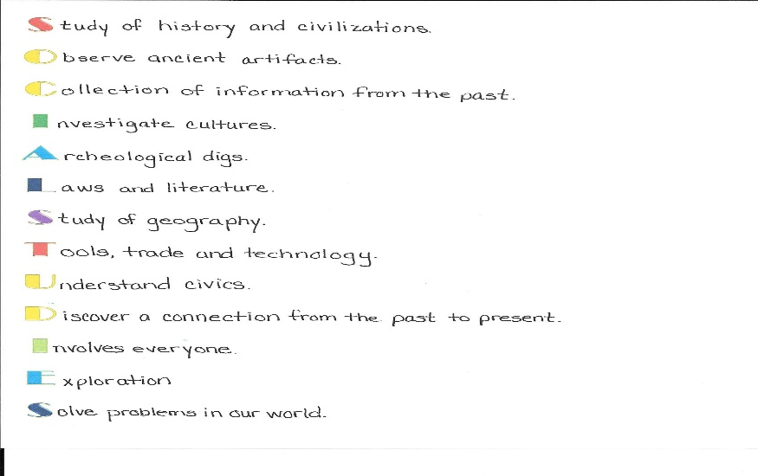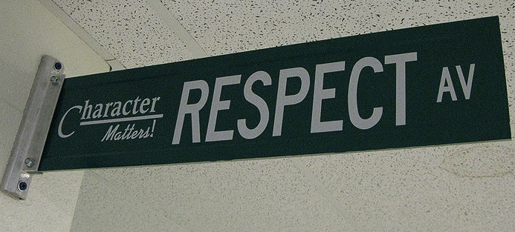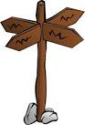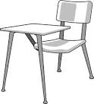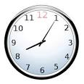

Welcome to Social Studies.

Our first goal this year is to look at World History and American History as a unified topic, History, rather than each independently. Our main themes will be the growth and change in American democracy and interactions with world forces, particularly nationalism and totalitarianism.

The study of Geography, understanding the spatial relationships between nature and human culture and processes that change environments is our second goal. You will learn about locations as well as the relationships between physical and human systems.

Discussion, both speaking and listening, as well as working in collaboration with others will play a role in class and help to prepare you for the college and career world. I look forward to spending the year learning with you!

Homework is not busywork. It is necessary for you to complete in order to participate in class the next day or to develop important skills. If you choose not to complete the assigned work, you are missing out on the opportunity to learn and grow. In the past, students who didn’t complete homework struggled to pass Social Studies, while students who regularly completed homework succeeded. Homework assignments may include, but are not limited to:

* Worksheets
* Topic research
* Vocabulary activities
* Projects
* Independent reading
* Responding to daily content

## Homework

# Course Description

#### Be kind & be respectful.

### Class Expectations

#### Follow directions the first time they are given.

#### Raise your hand and wait to be called on before speaking.

All school rules also apply.

#### Ask permission to leave your seat.

#### Be on time & be prepared.

SOCIAL STUDIES

you have 2 days for each day absent to complete and turn in the work. Being absent on a due date DOES NOT extend your time. Work is due when you return.

**Textbooks:** There is a class set of textbooks that remain in each desk. You may check out a book on a nightly, as needed basis. Checkouts are done after school and must be returned before homeroom. You are responsible for the book. You will be assessed a fine for damaged and/or lost books.

**Exiting Class:** At the end of class, you will wrap up what you are working on, return materials to the appropriate locations, and gather all your belongings. The teacher, not the bell or the clock, dismisses you.

## Classroom Policies & Procedures

**YOU WILL NEED:**

* 1 Orange 2 pocket pronged folder
* 1 Purple 2 pocket pronged folder
* 1 Color of choice 2 pocket pronged folder with paper
* Writing utensils

Pencils, extra lead if mechanical

Colored pens

* Eraser, in addition to one on pencil
* 1 box of colored pencils
* Planner (school issued)
* A Gmail account (sign up for one if you don’t have one already)
* A positive attitude, a sense of humor, & an open mind

**DUE BY: Monday, Aug. 14th**

**Entering Class:** Wait for ALL students from previous class to exit BEFORE you enter. Gather any necessary materials, quickly find your seat, and begin working on the warm-up posted on the overhead. If you are not in your assigned seat when the bell rings you will be marked tardy.

**Bathroom Usage:** You are to take care of this during your passing period. You will only be allowed to leave in an emergency.

**Food & Electronic Devices:** Classroom is a food & drink free zone. You may have and are encouraged to have a CLEAR bottle with WATER. **Gum** chewing is prohibited according to school policy and will not be tolerated in my classroom.

Electronics are to be **locked** in your locker and should not be seen or heard.

**Assignments:** All work will be done in pencil, unless otherwise instructed. Work not done in pencil will receive a reduced grade.Teacher will collect assignments. All assignments need the following heading in the upper right-hand corner: ***Last Name, First Name Date Class***

**Late Work:** NO late work will be accepted.

**Absences:** If you are absent, it is *your* responsibility to make up missed assignments/work. See the teacher for your “While You Were Out Slip”. Per school policy

Meeting classroom expectations and behaving appropriately in class helps to create a learning environment where you and your classmates feel welcome, safe, and respected.

If you choose to meet the classroom expectations, you may receive a **positive consequence**, such aspraise from teacher, classmates, administration, a positive note or phone call home, and awards.

If you choose not to meet the classroom expectations, you will receive a **negative consequence,** such as a verbal warning, a change of seat, a student/teacher conference, a phone call home, an after school payback, a parent/guardian meeting, and for severe infractions of school rules, an office referral.

## Positive & Negative Consequences