Westwood

Science Fair



2013-2014

Science Fair Project Guide

For official rules, forms, and information see:

[www.societyforscience.org/isef](http://www.societyforscience.org/isef)

<http://www.floridassef.net/>

http://www.sbac.edu/pages/ACPS/Departments_Programs/DepartmentsLZ/SciFair

**Helping Your Child with a Science Project**

Children are naturally curious. An excellent way to teach them to develop problem solving skills is to direct their curiosity toward scientific investigation. A scientific investigation that uses the scientific method helps develop your child’s thinking skills.

As a parent, you play one of the most important roles in your child’s education. The encouragement, guidance, and support that you give your child will not only help him or her develop valuable thinking skills, but the time you and your child spend working together will deepen the parent-child relationship that lasts forever. There are many things you can do to help your child with a science project without doing the project for them. Please check the official website:

[www.societyforscience.org/isef](http://www.societyforscience.org/isef)

Helpful Websites:

[www.societyforscience.org/isef](http://www.societyforscience.org/isef)

<http://www.floridassef.net/>

<http://www.sbac.edu/pages/ACPS/Departments_Programs/DepartmentsLZ/SciFair>

<http://sciencebuddies.org>

10 Tips for Helping:

1. This is your child’s project and should reflect his or her interests. Listen to their

questions. Those questions often make great project ideas.

1. Although this is your child’s project, and is to be his or her own efforts, there is no

substitute for your praise and support. Encourage your child and let him or her know you are interested in his or her idea.

1. Help your child with skills that he or she has not yet mastered, such as organization,

measuring, calculating, and construction.

1. Help your child follow the schedule to complete the project on time. Post schedule

dates on the refrigerator.

1. Provide a time and area in your home where your child can work without interference

from television or other distracters.

1. Help your child acquire the materials needed for the project.
2. Help your child take necessary safety precautions to insure a safe project.
3. Provide transportation to places such as libraries, museums, nature centers, and

resource persons, etc.

1. Realize that the real prize of a science project is the development of critical thinking

skills, not the blue ribbon presented by a science fair judge.

1. Contact us if you have questions.

**Rules**

The rules of the Westwood Science Fair are consistent with the Regional, State, and International Science and Engineering Fair (ISEF) and have been developed with the belief that all students should conform to the same regulations as those governing the work of professional scientists. The guidelines for some types of research, such as vertebrate (including human) experimentation, are particularly stringent. Adhering to these guidelines is not only a learning experience about what it is like to do real scientific research, but it also ensures that the students do not unknowingly violate state and federal regulations.

Therefore, as teachers at Westwood we strongly discourage students from experimenting with vertebrates of all kinds, including humans. We wish to avoid risks to humans and other vertebrates, and feel that the additional ISEF paperwork required for such experiments is often overwhelming for both the researcher and the human subjects. Please check the official website**:** [**www.societyforscience.org/isef**](http://www.societyforscience.org/isef) for more details.

**All projects conducted at the University of Florida must have UF environmental health and safety approval. Please check the following websites:**

UF EH&S: <http://www.ehs.ufl.edu/Bio/minors.htm>

Minor’s registration document: <http://www.ehs.ufl.edu/Bio/MinorReg.doc>

Minor’s biohazard info sheet: <http://www.eh.ufl.edu/bio/hzinfo.pdf>

Categories…

Listed below are the 13 categories designated by the Florida Science and Engineering Fair. Students select specific subject areas from these categories for their perspective project.

Behavioral and Social Science Environmental Science

Biochemistry Mathematics

Botany Medicine and Health

Chemistry Microbiology

Computers Physics

Earth and Planetary Science Zoology

Engineering

**Westwood Middle School**

**6th Grade Science Fair Due Dates 2013**

**Due Date**

**Topic** **Sept. 5**

Behavioral, Biochemistry, Botany, Chemistry, Computers, Earth and Space Science, Engineering, Environmental, Mathematics,

Medicine and Health, Microbiology, Physics,, Zoology

**Title and Purpose Sept. 12**

Title: In the form of a question (How does X affect Y?) Submit for approval.

Purpose: What will you learn and why is this topic relevant to the scientific community?

**References/Bibliography Sept. 19**

Five sources of information about your project. List them using the correct bibliographic format.

Include at least one book and one internet source.

**Review of Literature Sept. 26**

An original, three-page summary of all you have learned from the sources of information above.

This paper must be written in your own words.

**Hypothesis Oct. 3**

A possible answer or solution to your question, based on your research above. Should be written in an

“If…then…because…” form.

**Material and Procedure Oct. 10**

Materials: A list of the items necessary for you to perform your experiment. Procedures: A step by step description of

your experiment from beginning to end. Include a list of your independent variable, dependent variable, constants, and control.

**Experiment/ Logbook Oct. 17**

Begin collecting preliminary results. Bring Logbook to class for the next 4 weeks.

**Table, Chart, or Graph Oct. 24**

Assemble all data into appropriate tables, charts, and/or graphs.

**Analysis and Conclusion Oct. 31**

Submit a one-page summary of the entire experiment. Answer the following questions: Was the original hypothesis supported

or rejected? Why or why not? Was your purpose Achieved? Why or why not? Is additional research needed?

**Abstract Nov. 7**

A brief summary of your entire project. It should be no more than 250 words long.

**Final Bibliography Nov. 14**

A complete list of all informational resources used in this project.

**Rough Draft of Project Notebook Nov. 14**

Assemble all of the above steps, with a title page, table of contents, etc. and submit for editing.

**Final Draft of Project Notebook Nov. 29**

Assemble all steps in final form.

**Display Board Dec. 5**

Display boards should be neat and organized, with all steps placed in the proper location.

They will be presented in class.

**Westwood Middle School Science Fair Dec. 10**

**Alachua Region Science Fair at Santa Fe Community College Feb. 13**

**PROCEDURE FOR WRITING A BIBLIOGRAPHY**

**(WORKS USED LIST)**

A bibliography or words used list is a list of sources of information used while researching a topic. The bibliography should be in alphabetical order by author’s last name. If the author’s name is not given, list the title first and alphabetize it by the first important words of the title. Each bibliographical reference begins with “reverse indentation.”

All papers should be presented on standard sized white paper using blue or blank ink, typed, or word process. Please use the front side of the paper only.

**Remember you may use an online source like easybib.com It will help you through the steps with the ISBN.**

**I. For Books**

Author’s last name, Author’s first name. Title of the Book Underlined. Place of

Publication: Publisher, copyright year pages.

Example: Snow, Theodore P. The Dynamic Universe. St. Paul. Minnesota: West

Publishing Co. 2003

**More than one author**. Use the same procedure as above but include all authors.

If the book has an **editor**:

Editor’s last name, first name, Ed. Underline the Title. City: Publisher, year. Pages

used.

Example: Charbonnet, Sara, Ed. The World of Science Projects. Gainesville, FL:

Hogtowne Publishing Co., 2007, pages 4-19.

**II. For Encyclopedias**

Author’s last name, first name (if given). “The Title of the Article in Quotation Marks.”

Underline the Name of the Encyclopedia. Copyright Year. Vol, page

Example: McCarthy, Shawn. “Air.” The World Book Encyclopedia. 1999. Vol 1, page

564

**If no author’s last name is given**, start with the name of the article.

**Electronic**: Author’s last name, Author’s first name (if given). “Title of the Article in

Quotation Marks.” Underline the Name of the Encyclopedia. Copyright year.

**III. Magazine Articles**

Author’s last name, Author’s first name. “Name of the Article in Quotation Marks.”

Name of the Magazine Underlined. Month and year, Pages.

Example: Shrum, Susan H. “America’s Ancient Skywatchers.” National Geographic.

March 2003, pages 76-107.

**IV. Newspaper**

“Title of the Article in Quotation Marks.” Title of the Newspaper Underlined. Date,

page.

Example: “Westwood Students Excel in Science Fair.” The Gainesville Sun.

January 25, 2004, 1.

**V. Pamphlet**

Author’s last name, Author’s first name. (if given, otherwise skip) Title of Pamphlet

Underlined. City: Publisher, year of publication.

Example: Adams, Isabel. Identifying Rocks of Arkansas. Little Rock, University of

Arkansas Update, 2009.

**Pamphlet from a committee report of a company:**

Title of Pamphlet Underlined. A report by the name of the committee. Place of

publication: Publisher, year.

Example: Adolescent Stress Management. A report by the Committee of Adolescent

Mental Health. Washington, D.C.: Georgetown University Press, 2043.

**VI. Interview**

Last name of person, First name. Personal (or telephone) interview. Person’s title.

City, State, Date.

Example: Einstein, Albert. Personal interview. Professor of Physics. Not Really, N.J.

June 4, 2076.

**VII. Letter**

Author’s last name, First name. Letter to….Person’s title. City, State, Date.

Example: Bush, George W. Letter to Bobby Joe Smith. President of the United States.

Washington, D.C., Nov. 20, 2013.

**VIII. Television Program**

Program name underlined. Production company. Network name. Station call

letters, City, Date.

Example: Bill Nye the Science Guy. Science is Fun Productions. PBS. WUFT,

Gainesville, FL., Jan 28, 2009.

**IX. Internet Search**

Author’s last name, first name (if given). “Title” webpage sponsor. Date. <http address>

Example: Armstrong, Neil. “Science Fair Project Designs Moon Rocket” NASA.

Sept. 25, 1956. <http://spaceline.imaginarysite.nasa.gov>

**A CONTROLLED EXPERIMENT**

To conduct a scientific investigation care must be taken to follow experimental procedures. You must design an experiment to test the hypothesis. When planning your experiment, remember to keep everything the same (**constants**) except the single variable being tested (the **independent variable**). A **variable** is something that is changed in the experiment. It is what you are testing. Everything else must be the same and only one variable or condition is altered or changed. A control group should be used when conducting an experiment. A **control group** is a standard for comparison. This group receives the same attention as the test groups; however, it will not be influenced by the variable the other groups are testing. The variable measured as a result of the experiment is called the **dependent variable**.

Here is an example:

PURPOSE: The purpose of this experiment is to see if caffeine affects the heart beat of water fleas.

HYPOTHESIS: If water fleas are given soft drinks of different caffeine concentration, then the higher the caffeine concentration the faster the heartbeat because caffeine is a stimulant.

The INDEPENDENT variable will be the different amounts of caffeine used, so all other conditions will be kept constant. This means the following:

1. The water fleas must come from the same source and be chosen randomly.
2. All fleas must be kept in the same size containers, the same amount of water, etc.
3. All fleas must be kept at the same temperature.
4. More than one water flea should be used in each test group.
5. One group, the CONTROL GROUP, receives no caffeine.
6. Set up two other test groups (or different brands, whatever you decide), one receives a certain amount of caffeine, the other receives twice as much.



**LOGBOOK**

RECORDING OBSERVATION AND DATA

Use a separate notebook for recording all measurements and observations. This notebook is called the logbook. Record all information about your science project each day. Consider the following

* Make sure that you include accurate metric measurement in your data.

Give masses in grams, volumes in milliliters, and linear measurements in centimeters or meters.

* Keep lots of notes! It is better to have too much data than not enough.
* Do not erase. If you make a mistake, draw a single line over the mistake and make a correction next to it.
* Write down the date and time when making observations.
* Keep track of the materials used, their quantities and cost.
* Take photographs and video during your project. These can be used as part of your display board.

 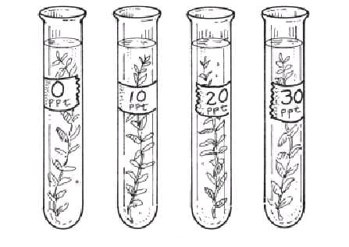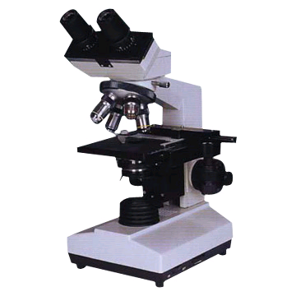 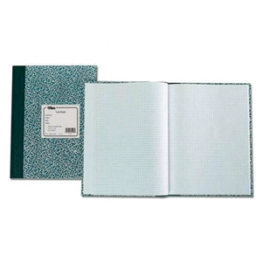

**How to write an Abstract**

Abstract must be on this year’s official Florida State Science and Engineering Abstract Form. (Check the web. It is not abailable at publishing.)]

Abstract Heading must be in the following form:

TITLE (IN CAPITAL LETTERS)

Last name, First Name, Middle Initial.

School, Alachua Region, City, State

(No Address, teacher’s name, school, references or bibliography should appear)

Abstract Text:

Write a one page summary (Maximum of 250 words.) It should include:

1. The purpose of the experiment
2. Procedures used
3. data
4. conclusion

It may also include possible research applications.

A copy of the abstract must appear on your display board. (see page 12) and you should keep several copies on hand to give to judges.

Be sure to answer the questions at the bottom of the form. Please read each one carefully and answer appropriately. Sign and date the form.

**PROJECT NOTEBOOK LAYOUT**

**Final draft should be typed, or written neatly in blue/black ink. Please use front side of the paper only.**

**MATERIALS**

List all the supplies needed for your experiment. Include amounts and sizes.

**HYPOTHESIS**

This should be one or two sentences that explain your “educated guess”

If…(Tell what you will do)…Then…(tell what you think will happen)….because (how can you explain your guess?)

**PURPOSE**

Tell what you are trying to show in your experiment and how this information can benefit humankind or expand scientific knowledge.

The purpose of this experiment is to find out….This is important because…

**Table of Contents**

I. Introduction Section

Purpose…………………………..…...6

Review of Literature……………..7

Hypothesis…………………………..11

II. Experiment Section

Material……………………………...12

Procedure…………………………...13

Date & Results…………….………14

III. Conclusion Section

Analysis & Conclusion………….16

Bibliography………………………..17

Acknowledgements…………….18

**ABSTRACT**

(see page 9)

**REVIEW OF LITERATURE**

Put your 3 page report here.

Make sure to re-number your pages if necessary

(Blank Page)

**TITLE**

(Put your title in the middle of the page in ALL CAPITALS)

**TITLE PAGE**

(Put your title in the middle of the page in ALL CAPITALS

Your Name

Period

School

Grade

Date

ScienceTeacher

**ANALYSIS AND CONCLUSIONS**

2-5 paragraphs that tell the results of your experiment. Restate the purpose. Explain: Did you accomplish what you wanted to? Would you do it the same way if you had to do it over? What additional experiments would you recommend to add to your research?

School

Grade

Date

ScienceTeacher

**DATA AND OBSERVATIONS**

Include everything that happened and what you observed as you did your project. Include charts, tables, graphs, and pictures. This section may be several pages long.

**PROCEDURES**

Give step-by-step directions of how to do your experiment

(blank last page)

**ACKNOWLEDGEMENTS**

(Optional)

**BIBLIOGRAPHY**

(see page 5-6)

Science Fair Display Board

Exhibit size is limited to: 76 cm (30 in) deep, front to back

122 cm (48 in) wide, side to side

327 cm (108 in) high, floor to top

The dimensions shown represent the maximum allowable size. It is not intended that each project will meet this space allowance. Smaller exhibits will be welcomed. Boards are available at office and discount stores, or from your teacher. Include photographs if possible.

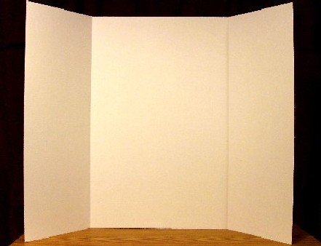

**CONCLUSION**

**PROCEDURE**

**MATERIALS**

**PROJECT NOTEBOOK**

**LOG BOOK**

**ABSTRACT**

**HYPOTHESIS**

**PURPOSE**

**PHOTOGRAPHS**

**GRAPHS**

**PROJECT TITLE**

**PRESENTATION TO JUDGES**

**This is an important part of your project so take the time to plan and practice the presentation you will make to the judges. Plan in advance what you want to say but don’t memorize your presentation. Write key phrases or ideas on index cards and use them as a reference, but don’t depend heavily on them.**

**Here is an approach you may wish to use for making your oral presentation:**

1. Greet the judges and introduce yourself.
2. Give them a copy of your abstract and research paper.
3. Give the title of your project, your grade, school, and sponsor (teacher).
4. Tell how you became interested in this topic.
5. Give some background information about the topic.
6. State the purpose of your investigation.
7. Discuss your review of literature.
8. Describe in a step-by-step fashion the procedures you followed for conducting your investigation. Point to sections of your display and refer to charts, graphs, and photographs. If you have equipment on display allow the judges to examine it.
9. Explain the results of your experiment and be sure to discuss controls and variables. Remember to keep all measurements in metric units.
10. Identify the conclusions that you could logically draw from the experiment.
11. Discuss any future plans you may have to continue research or experimentation related to your topic. Include a few statements about any changes you made in your scientific approach during your early investigation.
12. Ask the judges if they have any questions. Remember if you don’t know an answer say so and indicate you will look into it. If judges insist on asking questions in unrelated areas, redirect the conversation back to your specific topic.
13. Thank the judges for their time and any suggestions they may have offered to improve your project.

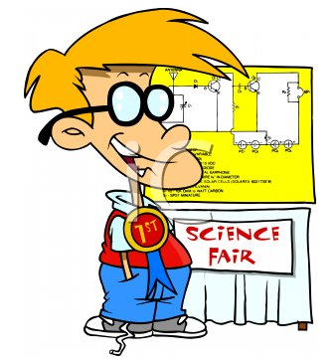**Good manners, nice clothes, and enthusiasm for what you are doing will help you impress the judges. Here are some tips:**

1. Wear nice clothes.
2. Be polite and practice good manners.
3. Make good eye contact with the judges.
4. Stand up straight and to the side of you exhibit.
5. Speak with enthusiasm, clarity, and assuredness.
6. Don’t do anything distracting.
7. Relax, Smile, and have FUN!