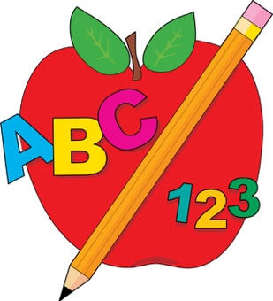 ***Ms. Melillo’s Pre-K 5***

***September 2017***



***Schedule:***

7:30- Arrival Time

7:45 -8:15- Breakfast/Table Toys

8:15-8:30- Circle Time

8:30-10:30- Center Time

10:30-11:00- Lunch

11:00-12:00- Gross Motor

12:00-1:00- Nap Time

1:00-1:15- Snack

1:15-1:45- Center Time

1:45-2:00- Afternoon Meeting

2:05- Dismissal

**Important Dates:**

9/7: Orientation

9/8: Half Day 7:45am-10:30am

9/11: After School begins

9/19: No School

**Welcome to**

**Ms. Melillo’s Pre-K 5!**

Dear Parents/Guardians,

The first few weeks of school will be an adjustment for your child into the school setting. In Pre-K your child will be able to grow in several different ways. Your involvement will help make this year great. For the next few days we will be working on classroom rules and routines and how the classroom works. For the next few weeks after learning how the classroom works, the unit we will be working on is called “All About Me”. This topic will allow the teacher and other students to learn more about the student. I am looking forward to this year and to it being a year of growth and learning!

**Important Reminders:**

* Class begins at 7:45am and is dismissed at 2:05, it is important that your child is on time
* Please sign your child IN and OUT everyday
* Please label all of your child’s belongings with their name and Pre-k 5
* Please check and empty your child’s folder daily as important things will be sent home frequently
* Every Friday blankets and sheets will be sent home to be washed and to be returned on Monday

**Email: gmelillo@stlucys.org**