Algebra Two
Rules, Regulations, and Expectations

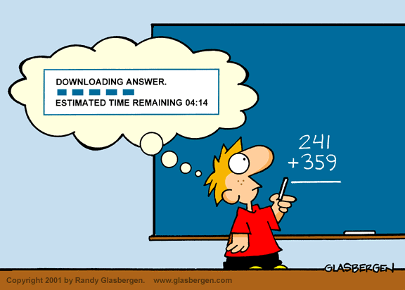

Instructor.
Dr. James Reagan
Class Days: MTWR Classroom: 119
(908) 889-1600 x. 330 Email Address: jreagan@unioncatholic.org
Webpage: schoolnotes.com/07076/reagan.html

Office Hours.
My office is located in Student Affairs. I am available after school or by appointment.

Textbook Requirement.
Holt Introductory Algebra 2. Written by Russell F. Jacobs. Published by Holt, Rinehart, and Winston/Harcourt, Brace, Jovanovich. Textbooks must be covered by Monday, September 18, 2012 and must remain covered for the duration of the school year. Each student will be issued a specific text. If the textbook is lost or damaged, the student will be charged.

Materials Requirement.
- spiral bound or marble notebook containing at least 200 pages (for math use only)
- calculator (do not go out and purchase a Texas Instrument calculator)
- pens (black or blue only) or pencils
- laptops at all times
- loose-leaf paper

Classroom Rules.
- Be on time to class – lateness is not acceptable.
- Class begins at the second bell. Be seated and ready to work. Come prepared: text, pen, pencils, notebook, loose-leaf paper, and laptop.
- Take care of bathroom needs before or after class. Remember all your belongings; you are not permitted to go to your locker during class.
- If you have a pass to leave early, show it to me before class. It is your responsibility to get the correct assignment for that class.
- When I speak, I will be the ONLY one talking.
- Windows, shades, lights, SmartBoard, TV, fans, etc. are off limits to students.
- Don’t even think about combing hair or applying makeup in class. These items will be confiscated.
- For the boys, the collar must be buttoned to and at the neck with the tie worn pulled up to the shirt collar.
- Late homework is not accepted. Homework is considered late if you do not have it in class with you. If you have difficulty with an assignment, I expect to see you either before or after school.
- All tests will be announced; you can expect at least three quizzes a week.
- I expect polite and courteous behavior at all times.
- We will follow the 5 Union Catholic core values of: community, compassion, honesty, responsibility, and respect.

Attendance Policy.
Regular attendance in this class is strongly urged. Students are responsible for all announcements, assignments, presentations, etc. which are made in class. You should be aware that missing class could adversely affect your performance on assignments, homework, tests, journal entries, and exams. It is your responsibility to obtain all materials missed.
Students who exceed sixteen (16) absences for a full year course may not qualify to receive credit for the course.

Grading.
Tests 60%
Quizzes 30%
Homework 10%

Honor Code.
In accordance with the philosophy and mission of Union Catholic High School it is expected that a student’s conduct will be characterized by a sense of honesty and integrity. Violations are lying, stealing, and cheating in any and all of their various academic forms. Examples include, but are not limited to:
- The use of another’s language as if it were one’s own
- Copying another’s answers or providing questions in an exam, test, quiz, etc.
- Discussing answers during a test
- Using unauthorized material
- Attempting to obtain copies of a test or exam before the test or exam date
- Being in possession of a copy of a test or exam before the test or exam date

The penalty for academic dishonesty is an automatic F for the assignment or test. A report will be made to the Assistant Principal. Subsequent offenses could be the reason for dismissal from school.

