May Literacy Circle

Due: May 26, 2017

This month, students will select a poem containing at least four lines to memorize and recite to the class. In addition to memorizing the lines, the students will score the poem for actions and tone. Please see the example below for clarification.
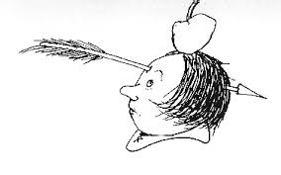
Advice by Shel Silverstein Action Tone
William Tell, William Tell | Cup hands to mouth | excited
Take your arrow, grip it well, | Make bow & arrow gesture | concentrated
There’s the apple -- aim for the middle -- | Motion to “apple” on head | concentrated
Oh well...you just missed by a little. | Point to forehead | painfully

Students should practice their poem in front parents/siblings/friends/mirrors to better prepare for their presentation to the class!

*Remember to bring a paper copy of your scored poem for your teacher

