s

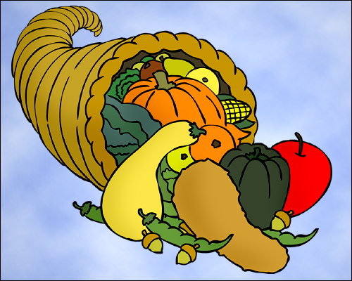
Music Class News

WINTER 2012

Music Reading

Once our essays are complete, we will continue on with our music reading study. We will be exploring sharps, flats, key signatures, scales and dynamic markings in music. As our knowledge of the written language of music increases, so will our ability to perform successfully on the instruments. Remember, music learning is always a work in progress-there is always something new to learn.

Mozart 5 Paragraph Essay

All classes are working on the expository writing assignment which consists of a five paragraph essay on Wolfgang Mozart. It is my hope that not only will we learn about the life of one of the greatest composers in history, but also how to read for information and to compile that information in a logical fashion. Classes spent time reading from a source, using a graphic organizer to take notes, reviewing vocabulary from the article and finally writing the essay. In the process we also learned how to cite sources using MLA style, a skill which will be very helpful in high school and beyond. Some tips for success:

  - When finding information, consider your source. Use high quality books and web sites which give you accurate information on your subject.
  - Cite sources-if what you are writing is not your own, you need to cite the source.
  - Remember to think about the bigger picture when writing about your source, Mozart’s world was a lot different than ours!
  - Do not be afraid to use an atlas, timelines or other sources to learn about the composers homeland and place in history.

Instrument from Home

I strongly encourage students to bring in instruments from home so that they may learn them in class. If you ever have questions about guitars, keyboards or other instrument, do not hesitate to contact me. Most times a simple fix will get that instrument working fine.

