_______________Name
___________Core
____________Date

Kyle Olsen’s Ecosystem Study Guide.
Ecosystem Autotroph Organism
Abiotic Independent Photosynthesis
Second Dependant Food Web
First Adaptation Food Chain
Third Biotic producers
Consumers Decomposer population

- If you are alive you are _______________.
- Producers make their own food through _______________.
- A ______________ is a chain of animals eating each other and passing on energy.
- There are five main _____________ factors.
- __________ eat dead animals and break them down.
- The _____________ level consumers eat the plants.
- The ____________ variable is the one thing that changes in an experiment.
- ____________ are another name for a producer.
- The ____________ variable is the effect of the independent variable.
- Many animals in the desert use _________ to help hold water or blend in.
- _____________ are all the organisms (animals) in one area.
- Animals that eat are called ______________.
- ___________ level consumers eat the second level consumers.
- The ______________ level consumers eat the first level consumers
- An ___________________ is a living creature.
- _______________ uses sunlight, carbon dioxide and water.
- A ______________________________________ is a complex web of how the animals pass energy.
- Population is the amount of animals that live in an ecosystem.

List the following in the columns below.
Bird
Algae
Plankton
Invertebrates
Bush
Mushroom
Osprey
Swan
Bacteria
Tree
Fern
Lion
Worm
Dog

Producers | Decomposers | Consumers

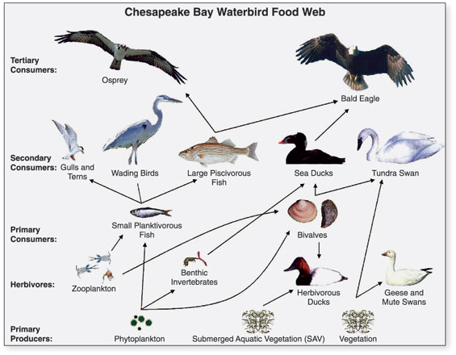

Mark all of the producers by circling them

Fill in the blanks

The osprey eats the ____________.
The bivalves are __________________.

