States of Matter Worksheet
Characteristics | Solid | Liquid | Gas
Shape | definite | indefinite | indefinite
Volume | definite | definite | indefinite
Examples | Ice  Rock  Book | Water  Gatorade  Milk | Water Vapor  Air  Helium
Picture of molecules | 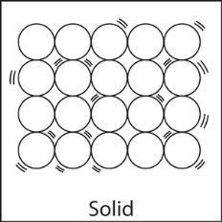 | 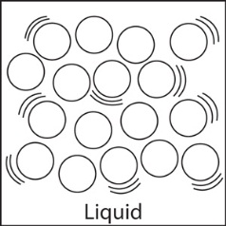 | 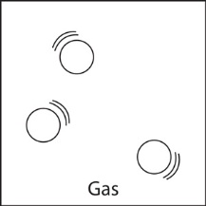
Energy of molecules | Low | Medium | High
How molecules move | Vibrate in fixed positions | Slip and slide by each other | Spread apart and move rapidly
Plasma
Characteristics: Electrically charged particles, molecules are spread apart more than a gas, high heat energy
Examples: Neon lights lightning stars Northern Lights (Aurora Borealis)
5th State of Matter: Bose-Einstein Condensate

