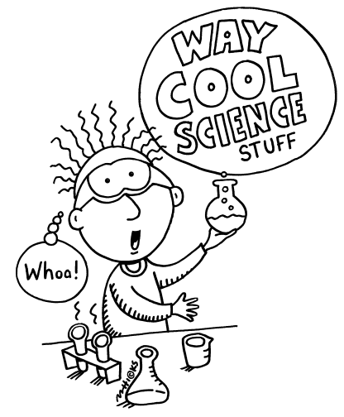Name_____________________

Date______________________

Core_____

**Variables Notes**

**Related to Dig-In (Clay, Sand, and Gravel) Lab**

Now that you have had some experience conducting experiments, you’re going to become experts on identifying variables!

INDEPENDENT VARIABLE

(CAUSE)

DEPENDENT VARIABLE

(EFFECT/ RESULT)

**Independent Variable:** (Cause) - Factor in the experiment that a scientist changes. It is usually the one thing the scientist is doing differently. It’s the treatment in the experiment.

**Dependent Variable:** (Effect) - It is what’s being measured in the experiment.

You can find the independent and dependent variables by looking at the PROBLEM or SCIENTIFIC QUESTION.

**PROBLEM/ SCIENTIFIC QUESTION:**



INDEPENDENT VARIABLE DEPENDENT VARIABLE



How do different types of soil (clay, sand, and gravel) **affect** the amount of time it takes for water to travel through them?



You can also find the independent and dependent variables in your hypothesis, if it’s written in the proper format.



INDEPENDENT VARIABLE

**HYPOTHESIS:**

**If** water is poured through different types of soil (clay, sand, and gravel),



DEPENDENT VARIABLE

**then** the water will move fastest through the gravel, less quickly through the sand, and slowest through the clay



**because** gravel has the biggest particle size, whereas clay has the smallest particle size.

1. What was the **independent variable** for the Clay, Sand, and Gravel Lab?



Different soil types (clay, sand, and gravel)

1. What was the **dependent variable** for the Clay, Sand, and Gravel Lab?



Amount of time it takes for water to start dropping out of substance (Percolation rate)

Now let’s focus on identifying the **constants** or all of the variables you needed to control and keep the same.

**Constants:** All factors that have to be kept the same in an experiment.

List all the **constants** in the Clay, Sand, and Gravel Lab:

* Same amount of water
* Same timing method
* Same stopwatch
* Measure the water at the meniscus
* Same graduated cylinders and beakers
* Same type of stocking
* Same placement of the stocking over the plastic bottle
* Same type of plastic bottle