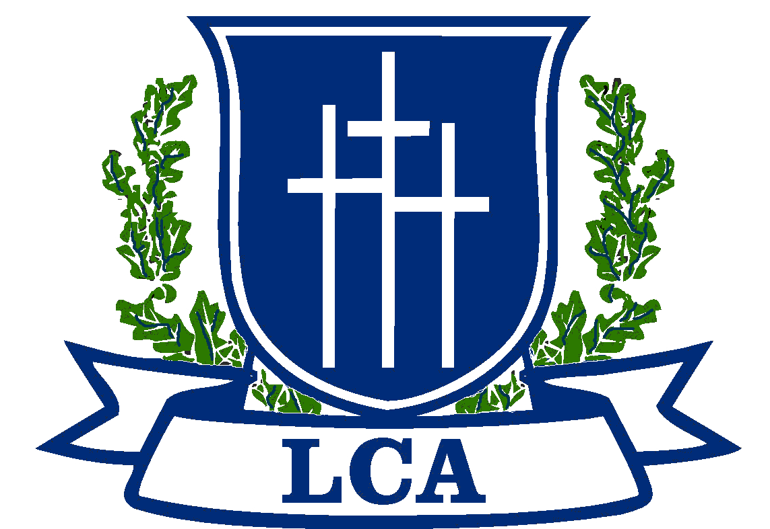
Lakeland Christian Academy
Secondary Choir -- Syllabus
I will be glad and rejoice in thee: I will sing praise to thy name, O thou most High. Psalm 9:2
Grading policy:
Daily Participation Grade (70% of the six weeks grade): 100 points total per day.
- Music Binder with Assigned Music 50 points
- Pencil 10 points
- Good rehearsal etiquette* 40 points
* Rehearsal expectations include active participation in warm ups, sight reading and rehearsal. Additionally, the student is to abide by the classroom rules of no food or drink and no gum chewing.
Performances (30% of the six weeks grade)
- Performances are mandatory. In the event of an unavoidable absence, an alternative assignment can be assigned to replace the concert grade. The assigning of an alternative assignment is at the discretion of the director.
Course Objectives:
- Students will master basic music symbols and terms, rhythm notation and sol-fege dictation.
- Students will learn and demonstrate proper rehearsal procedures
- Students will learn and develop sight-reading skills
- Students will learn and demonstrate proper vocal techniques
- Demonstrate a knowledge of vocal anatomy and phonation terms

REHEARSAL EXPECTATIONS
During rehearsals and performances, students are expected to be on time, not to talk or distract, and use good judgment when working with other people, equipment, and the room.

