
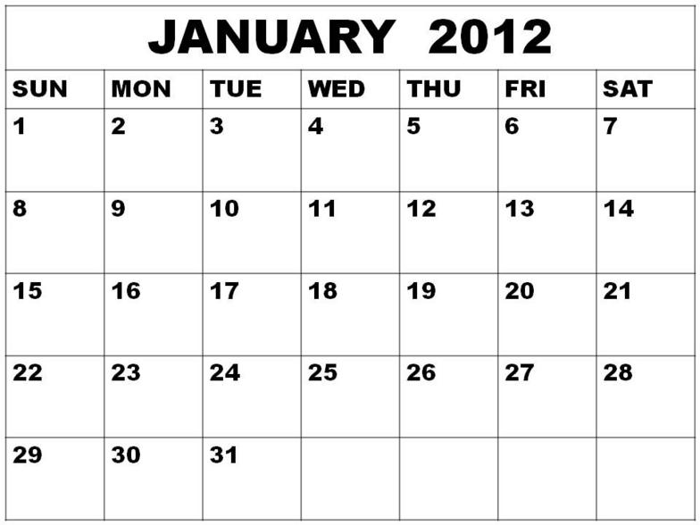
South
Forr.
Away
Sumr
Away
Conf.
Tour.
Topek
Conf.
Tour.
Topeka
Conf.
Tour.
Topeka
Sacred Heart
Home

5:30pm
Practice

