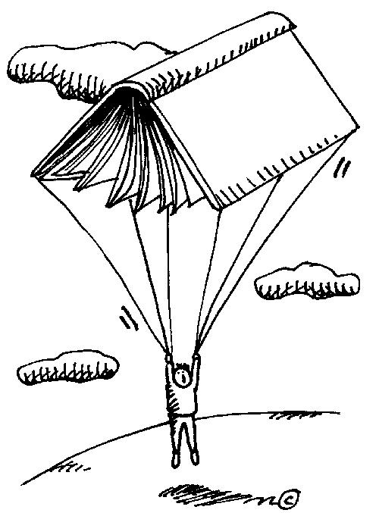

All clip art in Discovery Education's Clip Art Gallery created
by Mark A. Hicks, illustrator.

